**1962**

A golden year. (Well not for the lab animals, but best not to dwell on that.) Dad gets his first “real” job. They buy their first house, and a turquoise refrigerator, and some “best quality” furniture. Mom’s sewing machine survives another year of abuse. There are meetings and mumps and movies and murmurs. There is a gold brocade dress with matching gold shoes. And when Mom is in the hospital with a mild concussion Dad brings her a bouquet of flowers he cut from the yard.

**1-2-62** – Mom writes – Dear Aunt Clara, Thank you for the check – it’s to go toward the down payment on a house. We’re beginning to be rather anxious to be permanent somewhere!

We’re enclosing a picture of the kids Christmas morning – one of the few we were able to get of all three. Lisa is playing with the housecleaning set from Jimmy and Jana Kay. You can’t see it, but she’s sweeping the floor. Lesle’s keeping a close eye on her. Alan has just finally put down his apple to play with a toy. His favorite gift of the morning was the apple in his stocking. They (girls) each got a buggy and a cradle and you can just see a corner of their spring horse.

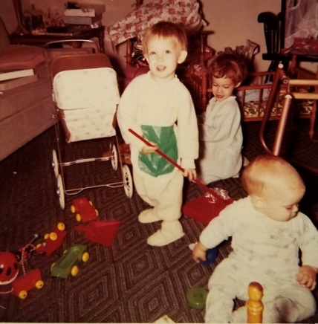

Alan is walking now and quite proud of himself. For the most part he disdains help now, though when he’s tired he wants help. He literally runs if he’s holding on – especially if he’s just been told “no, no!” The kids all got to play outside in the snow today for the first time since before Christmas. Alan and Lesle thought the snow was wonderful, but Lisa (who’s not much of an outdoor girl anyway) hey! didn’t care much for it. She kept saying she couldn’t walk.

We all have some cold now, but Lisa seems to be over whatever she had last week. At least, she hasn’t a fever any more and seems to have just about her usual energy. We had a quiet New Year’s Eve – just stayed home and relaxed after all our social life. The kids had Carroll home so much during the day during the holiday season that they could hardly stand it today when he had to go to work again. Alan was especially glad to have his daddy home tonight.

How soon will you be heading South and how long will you stay? Will your address be the same as before? Carroll wants to get to work early tomorrow, so I’d better get to bed so we can get up. Thanks again!

**1-?-62** – Mom writes – Dear Mother, I’ll write this time since Carroll is kept quite busy being chief cook, bottle washer, and baby tender. (I have the mumps, but Carroll says it’s safe to write since I just washed my hands.) Did Carroll have mumps?

We just got back from Decatur, Ill., where Carroll had a job interview at Irwin, Neisler & Co., a small drug house. Everything looked very good, just about ideal as far as Carroll’s work is concerned, so we may move there in April. We went down Thurs night because the weather forecast was not good. We were there all day Fri, and Fri night, and drove back yesterday. By the time we got to Chicago driving conditions were pretty bad, but by leaving early we avoided any real trouble.

You’ll be pleased to know that Carroll now has a new topcoat. It’s a gray tweed with a zip out lining – very warm and very sharp looking!

Alan had a pleasant birthday. We had the Tanakas (he works at Carroll’s lab) out for supper. They’re to be in the United States another year and then plan to go back to Japan. His cake was a cupcake baked in an ice cream cone (we always have cupcakes for the first birthday) with one candle, of course. When we get them back we’ll send you a copy of his birthday pictures. (I was going to enclose some of the Christmas pictures, but can’t seem to find them right now.)

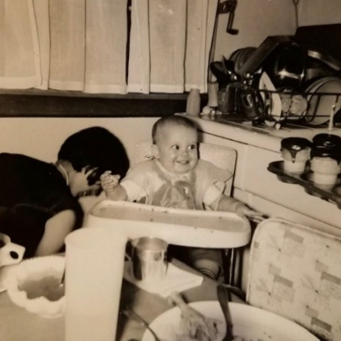

Alan eyeing his cupcakes.

I don’t remember when Carroll wrote last, but we haven’t done anything spectacular I’m sure, since then. We did go to one of the neighbor’s last Wed night for a post New Year’s celebration, but that’s all, I guess. Carroll will read this and may add more if he wants to (he does not) – I can’t seem to think of anything more right now. Love from all of us.

**1-14-62 – Sun afternoon –** I forget when you said Aunt Clara was leaving so if she already has you can send this on. I assume Uncle Clyde is there with you. It started snowing during church and is coming down quite hard now. With our 2 big snows already, and our bitter cold spell, I think we’ve had enough winter already. I guess we had a mild winter here last year, but this year is a little more than they usually have. One 3 day stretch last week when it didn’t get above 0 was the coldest such stretch since 1936.

Ruth stayed home this morning with Alan and I took the girls to church. We had to go early since I had a choir rehersal at 10:00, before church. The girls stayed in the basement and colored while I went. Lesle is doing much better at s.s. now and talks to her teacher. Alan had a runny nose and Ruth thought it best to stay home since she was still a little sore from the mumps. Her swelling is almost gone however. We stopped for groceries on the way home from church. We’ll stay at home the rest of today and nothing much this week except choir practice Wed and Ruths birthday on Thurs.

I went ahead and took the mumps vaccine shot last Mon night after I called you. Since there was some uncertainty I’ll have to take a 2nd shot tomorrow. It’s unlikely that the children will get it, but if they do the Dr. said to just let them have them as it’s not so hard on children. Ruth’s s.s. class is the 1st grade so it seems likely that that is where she was exposed, since nobody on our block here has had them as far as we know.

Alan walks quite well now and has just started pointing his finger at everything. He doesn’t say many distinct words yet but many of his sounds indicate he’s trying. Now that he walks he’s up getting into everything he can get his hands on. We have to keep chairs in front of the basement steps so he won’t fall down.

As I inferred over the telephone I’m accepting the position of research pharmacologist with Irwin, Neisler & Co. of Decatur, Ill. We’ll move sometime in April, and will still try to take the Kansas vacation just before I start work. I’m supposed to give a paper again in Atlantic City the first part of April. This company has annual sales of 5-6 million which makes it much smaller than the largest companies such as Lilly and Parke Davis (the ones I visited when I was in pharmacy school) which have sales of around 200 million a year. It is an old company and just started a research program in 1950. More than half of their sales are from products developed through their own research. All their drugs are sold for prescription use and they have about 150 salesmen over the country that visit physicians. They are interested in “novel” different types of drugs and believe in slow growth. The only other pharmacologist they have is director of all the biological work and so doesn’t have too much time to devote to basic research. Dr. Chester Cavalitto is the director of research and is a chemist. They are the 2 men I would mainly work under and with, although they have several PhD’s in chemistry which I would have contact with.

The research is all in a brand new building with a total of 35 employees. There are about 150 employees at the manufacturing plant which is at a different location in Decatur. I should not have to drive more than 15 minutes to get to work. Decatur is about 75,000 and is within easy driving of St. Louis and Chicago, and along 1 days drive to Hutchinson or Oberlin. The schools are said to be quite good.

My starting salary will be $10,200 which is competitive with the larger companies, and they have a profit sharing program for retirement. They are privately owned – not a corporation. There will be a chance for a raise at the end of 1962 and subsequently. They will pay moving expenses. Although some medical school might pay almost as much starting salary, the long term financial return would not be as promising. I have become disenchanted with teaching positions because of the time involved in many academic details, time spent on lectures, and the great pressure to publish or not be advanced. To do a good job at both teaching and research is getting to be more difficult all the time. Graduate student teaching would be of interest but I have made my decision in favor of industry.

I had planned to go down to Decatur with Dr. Abood, but when everything sounded so good I talked to Dr. Sherrod (negro pharmacologist here) and he knew about the opening and immediately got me to call Dr. O’Dell and I decided to go right down a week ago Fri. A week ago Thurs night the weather report called for colder and snow so we all left that evening after work. It was a 4 hr drive and rained all the way. We stayed in a motel and all day Fri I talked with the men. Dr. O’Dell showed Ruth the town. We’ll rent a house with an option to buy and not necessarily a new one since we’ll need lots of room. Fri night Dr. Cavalitto’s daughter and friend stayed with the children and we went to their house.

The weather held above freezing until Sat morning when we left. We made it to 66 at Bloomington before the slush began to accumulate and from there on had freezing rain, sleet and snow all the way. We just made it before the going got too rough and slow. By Sat night Ruth was quite swollen with the mumps and we missed church on Sun. I stayed home from Mon to Thurs during the bitter cold and while Ruth stayed in bed. We made it OK. The car wouldn’t start Thurs so had it towed over to station. I went to work Fri and we were home yesterday. Hope you’re all OK and the snow hasn’t been too bad there. Don’t try to shovel it. I guess we won’t get to Madison till the weather is better.

**1-26-62** – Mom writes – Dear Mother, Thank you for the check – I’m going to use it for some much needed house slippers. If the weather isn’t too bad I’ll go shopping tomorrow. Carroll gave me the first good shoes I’ve had since we were married (stacked heel, glove leather pumps) and the kids gave me a Wagner Ware saucepan with pouring lips so it’ll be easier to pour cocoa. Since I had a check-up at the hospital on my birthday, Carroll took all 3 kids to the lab (they thought it was great fun to eat lunch with him) and they took me to a restaurant for supper.

We were sorry to hear you were sick – hope it’s all cleared up now. Mary Janet called us from the airport, but there wasn’t time for Carroll to get home and to the airport before their plane left, so we just visited a little on the phone. Has Aunt Clara gone south yet? Or haven’t you been able to talk her into it yet? The girls and I went shopping yesterday for material for our spring coats and suits. I’ll have to get started on them soon. When we got home, we found Alan had slept most of the time we were gone, had vomited and was asleep again. He didn’t eat any supper and then was up from 3-4 this morning, but seems to feel fine this morning. Of course, we’ll keep an eye on him. Better stop now – mailman could come any time. Thanks again!

**2-4-62 – Sun – 11:00 AM -** I’m staying home from church with all 3 kids while Ruth goes to teach her class. Lesle finally started coming down with the mumps yesterday and is quite swollen today. She doesn’t feel too badly, however, and has been up playing with Lisa all morning. We’re deliberately exposing Lisa again and hope she gets them since it is so much easier on them at this age. Alan has certainly been exposed but we’re not sure whether he had a mild case, or not. Boys, especially, should have the mumps early to avoid later trouble. Alan still has some immunity and may not get them.

Yesterday and today have been warmer and the snow is melting some. We’ve had several small snows since our big ones and everything is still covered. The main streets are in good shape but the side streets still have some snow. I’ve had all the winter I need already. M.J. called us from the airport both going and coming, but, as you know, we didn’t have time to go out and see them. We’ll drive up when the weather gets a little better. M.J. said you had been sick when she called. We hope you’re OK now. You better check with Dr. Paine if it happens again since I recall you had it another time or two. We hope Aunt Clara and Uncle Clyde are OK also.

We had planned to go to Carol and Jack Duvall’s last evening but had to stay in because of Lesle’s mumps. I went shopping in the afternoon and put the license plates on the car which I got last week. I need to take the car in for a check-up. We have to buy ($10) village car stickers, also. Today Ruth will stop at the drive-in on the way home. I’ll take this over and mail it this afternoon. I’m supposed to sing a solo at church a week from today. Next Sat night we have to help cook and serve for the Couples’ Club meeting. They have a committee of 5 couples at each meeting to handle the food. We had a meeting about it last Mon night. I went to choir practice last Wed night. We all made it to church last Sun. Thanks a lot to Uncle Clyde for the gifts to the children.

We didn’t mean that we were interested in a very old house, but only that we wouldn’t require a brand new one. We’re anxious for all the room we can get since we’re tired of being so crowded. Dr. Cavallito (the doctor of research) will keep his eyes open and start actively looking for something in March. Decatur is close enough that we can run down to look at anything that turns up. We’ll have to rent at first since we don’t have enough for a down payment and it might be wiser to rent initially since you might decide you didn’t want to live in that locality. Sometimes if you rent with an option to buy they will apply the rent as a down payment.

Decatur should be a few degrees warmer than Chicago, on the average, and I certainly won’t have as far to drive to work. It has recently been taking 1 hour to 1¼ hours to drive home from work in the evening, and usually 45 minutes in the morning. I’m getting quite tired of it. I received the renewal on my fellowship but they can be resigned at any time. I’m getting paid by the university now but will pay them back when I get paid for my fellowship from Nov 25 on. The 2nd year fellowship pays $7500 with $6600 tax exemption but even on that we wouldn’t be able to save much. Starting university salaries would probably be between $8000 and $10,000.

Dr Abood gives me a recommendation and I got one from Dr. Sherrod (negro pharmacologist U of Ill.) also. I got the job mainly on these recommendations. I have learned all I can from Dr. Abood as far as his research approach and since we differ considerably on our approaches I would only become frustrated if I stayed any longer. I feel the time has been worthwhile since I’ve become intimate with a whole area of research with which I wasn’t too well acquainted. I will have responsibility, but have been essentially on my own here. I have enough research ideas that I prefer to be my own boss research wise. I will have to work on some of the drugs Irwin, Neisler has but they are along my lines of interest and I will have plenty of chance to test my own ideas. We still plan to take our vacation the first 2 wks of April but don’t know yet whether it’ll be Hutch or Oberlin first. We’ll let you know. Show to all.

**2-21-62 – Wed night -** Dear Mother, Aunt Clara and Uncle Clyde, As usual, I’m late getting to the letter, and I really have no excuse. Thanks for all the valentines; the girls enjoyed receiving and giving valentines to some of the neighborhood kids. They’ve been playing outside more recently as the days have occasionally been warmer. We were glad to have your letter this week and I mailed it on to M.J. and Bill today.

I went to choir practice this evening. I’m finally singing a solo this Sun in addition to a solo with the anthem. That will probably be my last solo here. The choir here has had a lot of sickness etc. since Christmas; one of the former tenors is divorcing his wife who sings soprano – she was there tonight. We had 4 more inches of snow today but the temperature stayed high enough that the driving was not too bad. The side streets are snow packed but the main streets are clear. I’m really tired of it.

This Fri Dr. Cavallito, my future boss, will be here for a seminar so I’ll get to see him then. This next Sun evening we’ll all go over to Carol and Jack Duvall’s. Last Mon I took the car to a Ford place for a check-up and some needed work. They did $70 worth of work. Generally the car is still in good shape – it is almost 5 years old and we hope to keep it for some time yet. We were home Mon and Tues evenings. Last Sun we all made it to church. The girls looked nice in their new patent leather shoes which we bought on Sat. It snowed real hard as we drove home from church and we stayed in the rest of the day.

Last Sat we went to the shoe store and got the patent leather shoes plus new shoes for Alan and some cheap high top shoes for Lisa so she will stay in her splint at night. I bought a new pair also; the last pair I had were the ones you bought me in Hutch – they’re still in good shape. We had some credit at the shoe store since they give a pair free after you buy 12 and we had 11 pairs before Sat.

Dr. Walaszek is presenting a paper, which also has my name on it, at a New York Academy of Science meeting in March (22 and 23), so I guess I’ll go since there will be papers on work related to my thesis work. Trust you all are OK. Thurs – Mailing this from work – Ruth said the kids played outside some this morning even tho its colder.

**3-6-62 – Tues PM -** I’m quite late in writing this time and that was why I called last night; I hope Uncle Clyde relayed the message that we were all OK. I should have called later in the evening. We were glad to have your letter today and I’ll send it on tomorrow. It was good to hear Uncle Clyde’s voice. The weather has been cold and snowy again recently but the driving hasn’t been bad. We’ve had snow on the ground continuously since the middle of December. Lesle had a big birthday today and says “Thank You” for the card. Ruth and Lesle went around the neighborhood the other day and invited the neighbor children and their mothers to a birthday party. There were 13 kids with their 6 mothers. I guess they had quite a time. They had cupcakes baked in ice cream cones and Hawaiian punch. Lesle got 3 books, Mr. Potato Head (on TV), a wool pleated skirt and white blouse. Tonight Lesle had her family celebration. Her big cake was a “zoo” cake – chocolate covered animal crackers pressed on a rectangular cake. We gave her a pedal car and a junior stainless steel set (she was especially thrilled with the knife). Lisa and Alan gave her the book “New Shoes” and we got “Millions of Cats” for the Laidigs to give her.

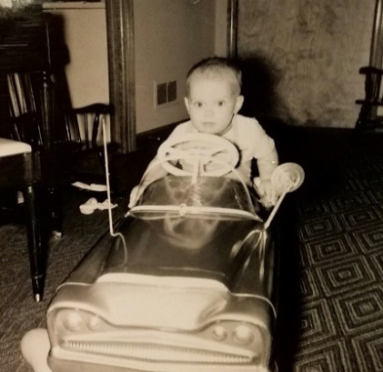 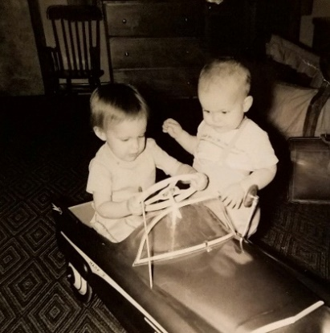

Everyone but Lesle in her pedal car.

Ruth and I went downtown yesterday to have our wills drawn up. Mainly to name Eldon Laidig as guardian in case anything happened to both of us. Ruth finished the birthday shopping downtown and we got a new phonograph needle so we wouldn’t be hurting some of our new records. Sometime we’ll get a new stereo record player.

I stayed home Sun with Lisa and Alan who had runny noses. We were supposed to visit Carol and Bruce Ferguson Sun night but something came up so we’ll go over next Sun night. Saturday the kids all had check-ups. Alan weighs 23 lbs 15 oz and is 29½”, Lisa is 24¾ lbs and 33¼” and Lesle 27½ lbs and 37½”. Dr. Keller thought she heard some heart murmur on Lisa and said it is probably functional and nothing to worry about, but to check it again later. My friend Dr. Mert Bernfield says one of the 2 best men to listen for murmurs in Chicago is at the Univ of Ill, so we’ll take her down for a check-up there as long as we’re here. Murmurs are not uncommon. Lynn Gerding, 3, next door, is to have a heart check this week, and the Cormans said their Brenda has one. The heart sounds are hard to distinguish on little children and many so-called murmurs are entirely physiological.

Sat night we went bowling with Carol and Jack Duvall (he’s the airplane mechanic at O’Hare – they came here from Pittsburgh). None of us did very well. We didn’t get home till 1:30 as we stopped for something to eat. Had a sitter. We went to their house a week ago Sun to help their Ricky celebrate his 6th birthday.

I go to New York the 23rd and 24th, and we’ll leave here Fri the 30th for Oberlin, trying to be there for Sun April 1. May go to Denver then to Hutch for Sun the 8th, and then leave in time for my paper at the meetings April the 17th, back home for Easter, and then move the week of April 23-27. I guess we’ll be busy (!). Hope you’re all OK and show to Aunt Clara and Uncle Clyde.

**3-18-62 – Sun 4:00 PM -** I’ll write this before we leave to visit Helen and Dale Johnson for supper. They’re the former Oberlin people who live in Evanston. We’ve been to their house a couple of times and they’ve been here once. Yesterday and today have been clear and warmer and a lot of the snow has melted. February and the first part of Mar were one of the darkest periods they’ve ever had here – the sun almost never shown. I had the car washed yesterday and was supposed to get a new tire but it wasn’t in so will go back this week. The Mobil man has to pick up a blackwall tire since he sells mainly the white sidewall. I didn’t want to buy 4 new tires right now and the white ones are mainly for appearance. Yesterday morning Ruth went for groceries and then took Lesle for a booster shot. The children are all finished with their appointments with Dr. Keller. In Decatur, we’ll need to find a new Dr. (a whole family one maybe) and a new dentist since Ruth and I need some work and the children need to get used to going to a dentist.

Yesterday afternoon I picked up a meat grinder and meat chopper which we got for Top Value Stamps. Alan finally has another new tooth (7) but still has trouble chewing meat. We cleaned the house yesterday afternoon and Ruth finished the new slipcover for the couch. It was quite a job but really looks professional. It matches the cover we had made for the big rocker and is more Early American style than it was before. The children must be careful to keep it nice and clean. Ha! Yesterday evening the Gerdings all came over for dessert and to listen to some records they have. There record player is worn out. Their 3 year old girl had her check-up and her murmur apparently is entirely functional. Lisa goes back next Thurs to the clinic for her report.

We all went to church this morning. Ruth has only one more time with her class and she says she’ll really miss them. She likes children about that age (1st grade). This coming Wed we’ll go downtown and sign the will at the lawyers, and then Ruth will have her final check-up with Dr. Truckly. The little difficulty she had had pretty much cleared up the last time she was there in Jan. Thurs I’ll leave by train for that New York meeting on Substance P (my thesis subject) and some other related substances. Ed will be there. We have so many things to do here I probably shouldn’t go, but I told him I’d try to make it.

The man at Irwin, Neisler called last week and said he’d send todays Decatur paper for us to check on housing. The way it stands we’ll leave a week from Wed and stop by Decatur on the way to Oberlin. Last week I went to choir and Ruth went to AAUW, we had a sitter. Last Sat (a wk ago) we went to couples club at church (had sitter). All went to church that Sun. Last Thurs night Ruth went to a party of her dept s.s. teachers at her superintendent’s house.

We were glad to have your letter via M.J. and Bill. We hope that Uncle Clyde gets along OK and maybe something will work out. Even if Lisa has something more than a functional murmur as long as she has no symptoms they do nothing and she could expect a normal life span. (I talked with my intern friend about the type of trouble she could have with the type of murmur heard.) She plays just as hard as Lesle and we notice nothing about her. I’m going to NY alone. My solos went OK. I didn’t use the one you sent but have sung it over and it’s real nice. Alan had a big time at Lesle’s birthday. Glad to hear all the news. We’ll have the mail forwarded to Hutch later. Ruth is starting to make spring outfits for the girls. We bought them some new play outfits. Mom adds: Lesle’s dress is lovely – she loves the horses. It’s quite large, but will try to make it smaller since a 3 might not fit either.

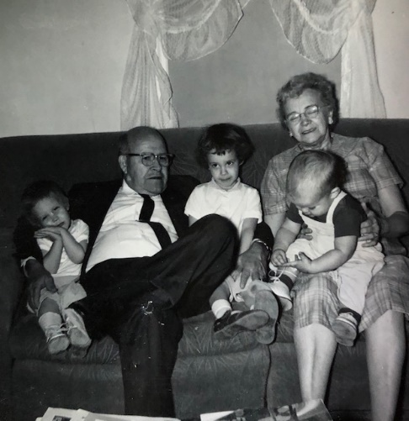

April in Oberlin.

**4-14-62 – Sat AM -** Stayed all night here in Monroe City will go on to Decatur this morning. Had good trip to Topeka and saw Ruth’s friend, to Lawrence and saw Dr. Wenzel and Ruth saw friend, and then stopped by Judy’s, on to Eudora and saw the Holladays that evening. Stayed in motel across from Med Center and then had good visit with the Moyes and I stopped by med center and saw Bob Legg and drove on here in the afternoon. Ruth was kinda sickish last evening – from all the curves I guess. Hope you’re all OK.

**4-17-62 – Ohio Turnpike -** Sat we went on to Decatur from Monroe City, MO. I went down and we filled out the FHA forms. It will take 4-6 weeks to close so we’ll probably move into a rental till the people are out (1st week in June). Mr. Laidig offered to help on the down payment (we’d pay interest, of course) so we may have to call on him. We drove on to Chicago Sat night and Sun morning almost decided not to come on since we were all so tired. However, I didn’t want to get Leo off so we came on. Ruth and the girls went to church and I rested. Since we didn’t get away till 6 we drove till 11. Stayed at Fremont, Ohio and will try to go on in tonight. Driving is OK since is turnpike.

**4-22-62 – Sun -** Well we made it back OK yesterday afternoon. Last Sun as I wrote you, we left about 6:00 PM. We rested up some that afternoon and I went by the labs to check the mail. We stopped at a drive-in on the way out of town and then drove on to Fremont, Ohio (on the Ohio Turnpike) where we stayed all night at a motel. We got there about 11:00 PM. The next morning we drove to Pittsburgh for gas and lunch and then on to Harrisburg for supper. Drove on to Atlantic City that evening. The motel reservation I had was filled since I had the reservation sent to the lab and they had wanted a deposit to hold it. It was at a close-in motel but was $22 a night. It worked out for the best as we drove out a ways and got a motel for $12. The next morning Ruth drove me down to where my paper was (hotel) and then went back to the motel where she made a skirt with some pleated material that Esther (John Laidig’s) sent at Christmas.

My paper went OK and it was lucky I went since Dr. Tom O’Dell (from Irwin, Neisler) was there. Didn’t see any of the Kansas men although I met a few friends at registration. After the paper I took a cab back to the motel and we had lunch in the motel restaurant. After that we all drove to the beach and the children played for about 2 hrs. Ruth found a piece of driftwood which we brought home for future use some way. The sun came out enough so that it wasn’t too cold although it was pretty chilly in the mornings and evenings. We had supper in the motel room that evening and all went to bed early. Since we hadn’t told John’s the exact time we’d be there we called them that evening and said we’d be up the next afternoon. We took our time and rested some the next morning and had lunch before the easy 2 hour drive up to their place at Chatham, NJ. Got there about 3:00 PM and Aunt Esther called John; he left work early and we all drove to see the many cherry blossom trees in a Newark, NJ park. Came back – it was quite a long drive – had supper and visited during the evening.

The next morning we got away about 10:30 and drove to Harrisburg, Pa for lunch and then on to Pittsburgh for supper; got lost a little bit there as we got off the turnpike to find a Mobil station. We had 4 lane divided highway essentially all the way there and back; some of it wasn’t completed last year. We drove on to the Akron, Ohio exit that night and stayed there. Had breakfast Fri morning at a turnpike restaurant and lunch at a drive-in at South Bend, Ind. Got here by 4:30.

Rested and starting getting ready for the movers yesterday. The girls and Alan had your package and say “Thank You.” They dyed Easter eggs and Ruth helped them with an Easter egg tree. They had an egg hunt this morning. Ruth went shopping yesterday and Alan enjoyed playing outside – it was very warm. We all went to s.s. and church today. The church was full (2nd service) so we sang in the choir for the last time. The packers will be here tomorrow morning and the movers Tues, with unloading Wed. Our temporary address there will be 41 Whippoorwill Dr., Decatur, Ill.

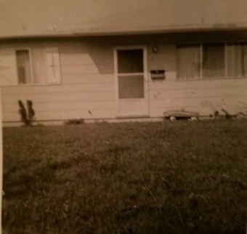 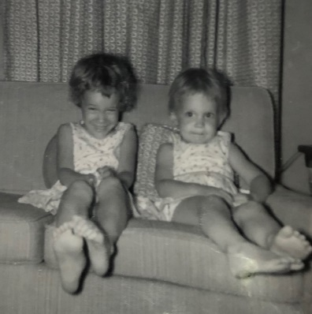

The transition house on Whippoorwill Drive. The picture on right is captioned “Lesle and Lisa in rental house.”

We may stay here in a motel Tues night and go down Wed. Here’s hoping you’re all OK and had a nice Easter.

**4-29-62 – Sun 8:00 PM –** I’ll write this now and then take it down to a mailbox later. I can’t seem to find a pen that writes among all our stuff. (This letter is written in pencil. Argh!) Had your card and a letter from the Laidigs yesterday, both our first mail addressed here on Whippoorwill. The Dahls who own the house we’re buying won’t be out till after school is over so we’ll probably be here till as late as June 10th. We’re paying $100 a month rent for the house here. It has no basement and no garage, but does have 1½ bathrooms and the closets are large. We’re gradually getting things in shape so it will be livable while we’re here. The girls are out playing with some neighbor children now. A lot of the people in this subdivision (called Larkdale) are young since you can buy these houses with no down payment. The house we’re in is to be sold but they’re having trouble doing it since for the same money they can get one that has never been occupied.

We all went to church this morning. We went to the one by Millikin University (Presbyterian). There is another large one downtown. We’ve been home the rest of the day. It was very warm when we arrived and Alan has sure enjoyed playing outside – he couldn’t walk last fall when it was last warm enough for him to do much outside playing. If M.J. called us we were gone. The packers came last Mon afternoon and did most of the packing. Maurine Lester called that afternoon so we all drove out to see them that evening. She served pie and coffee. The girls were good and played well. They have a house lined up in Denver. Margaret will stay on in Michigan I guess.

Last Sun we all made it to church. Ruth and I sang in the choir. In the evening we went out to see Carol and Jack Duvall’s new house and had supper with them. Tues morning I went to work and the movers came and loaded. I came home by 1:00 and we all had lunch at the Gerdings (North). The movers had loaded by 2:00 and it took us till 8 to clean the house and get all the little things jammed in the car. We drove a ways and stopped in a motel. We drove on the rest of the way Wed morning and found the van already here. Stopped by the lab some and got utilities started etc. I stopped by the building some on Thurs and Fri. The car insurance man was here Fri night. Yesterday morning we went downtown and opened a checking account and in the afternoon Ruth went grocery shopping. The distances seem so short compared with Chicago.

I’ll go to work all day tomorrow and subsequently I have my own desk and lab but no equipment. Hope you’re feeling OK. You better have that check-up. The mortgage has essentially been approved and will be fixed around the 15th with closing around the first. Show this to Uncle Clyde if he’s there. Our tel # is 877-6913. It’s 1.7 miles to work from here. 1/10 of what I was driving.

**5-8-62 – Tues PM -** I’ll use some of the Neisler paper so you can see what it is like.

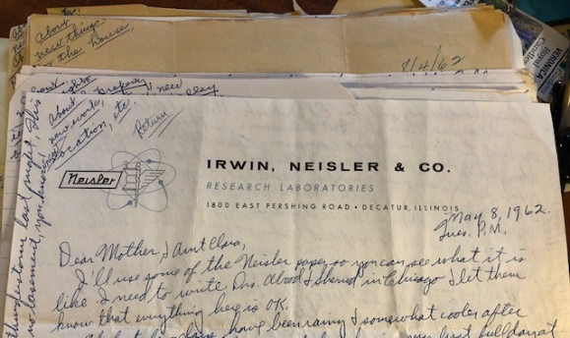

I need to write Drs. Abood and Sherrod in Chicago and let them know that everything here is OK. The last few days have been rainy and somewhat cooler after a warm stretch. A week ago yesterday, during my first full day at work, we had part of that storm you read about. As I went back at noon we had a regular dust storm. We had a thunderstorm last night. This house has no basement, you know. I’ve been driving home at noon for lunch since its so close. I’ve sure enjoyed that. When I start experiments I may want to work through the noon hour and will take my lunch.

We were glad to have your letter today and to know that you’re all OK. You’ll have to plan on coming to see us sometime after we’re settled in the other house. There wouldn’t be much point in anyone coming now since we’ll be leaving this house. I’m sure the Laidigs will try to come sometime, if they can leave Grandmother. He finishes his Rotary work before too long. We haven’t had any our magazines and other than first class mail forwarded. I’ve written about it. I signed the card properly to have it all sent on but they gave us trouble a year ago – on forwarded mail. My final government check came today but I have to return part of it for repayment of that salary they gave me. Irwin, Neisler and Co pays every 2 wks and I got my first check for 3 days of work last Friday. I like being paid oftener than once a month like I’ve always been before.

The people who lived in this house previously left town with a very bad reputation; they left many unpaid bills and nobody around here liked them, the house was dirty etc. The house is being handled for sale by Ed Drobisch, the real estate man we’re buying through, but the rumor is they plan to let it go back to the mortgage company. Their children ran wild and they did nothing about the yard. The backyard hardly has any grass and has been real muddy recently. The backyard at the other house will have to be partly fenced sometime. The neighbors, however, are very friendly and Ruth has two good friends already; both are younger than she is. They’re the “run in” kind of neighbors which she likes. Lorraine Brownfield (when we lived on the hill) was that kind.

Our moving bill was over $600 so it was lucky we didn’t have to pay it. We’ll borrow $1000 from Mr. Laidig to help on the down payment. We’ll need a total of about $1600 at the time of closing but we’ll have the $600 ourselves. We’ll have to spend around $400 later to convert the fireplace to wood burning. There’s no hurry on that.

Last Sun we went to the Westminster Presbyterian Church again. Its by Millikin University. There is another Presbyterian church downtown. I like my work fine and will run my first experiment tomorrow or Thurs. I’ll probably start on dogs using one the drugs that they hope to put on the market for use in high blood pressure. The work here will often utilize drugs they have on the market or hope to put on, and will, therefore, be closer to medicine etc. I got a lab setup from their big lab and will get more equipment in the future. The fellows are all real nice. There are 8 PhD’s and one MD (clinical director – he arranges for the clinical and hospital trials for the new drugs) at the research labs. 40 people all together. 6 PhD’s are chemists and 2 are pharmacologists. About 100 people work in the manufacturing plant downtown. The way I look at the job now it will be as permanent as I want to make it. The school at the other house – Dad draws a little map:

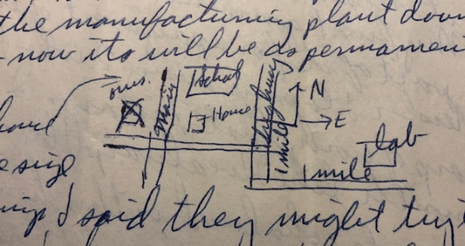 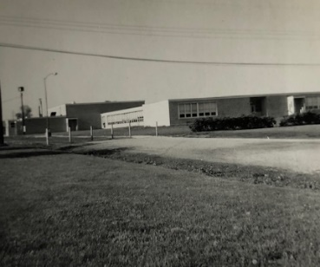

Mound School - Lesle went to kindergarten, 1st and 2nd grade here, Lisa went to kindergarten and 1st.

We like Decatur fine – nice size. M.J. sent on the clippings and said they might try to get down before summer school. We’ve been downtown shopping several times. Alan had a temperature yesterday so he went to a Dr. and is taking penicillin for a sore throat – he’s better today but still some fever. Here’s hoping you’re all OK.

**5-26-62 – Sat -** As usual, I’m a little later writing than I had planned on. We haven’t been too busy recently and we’re gradually getting used to the earlier schedule. It’s 5:00 now and I’m alone with Alan as Ruth and the girls went shopping with a neighbor lady who had missed her ride. As I’ve said before the neighbors are very friendly. Last Sun night I went along with Ruth and met one of the men. Alan is now very fussy and irritable. I hope he isn’t getting sick. We had him back to the Dr. again this week since he had another fever and sore throat. That was the 3rd trip to the Dr. since we’ve been here. I guess they’re picking up “new bugs” here to which they have no resistance.

This morning Ed Drobisch (the real estate man) was here with some people showing this house. He said we’ll close next Fri afternoon or Sat morning and the people will try to move the week of the 3rd and be out not later than the 15th. The other address is 3649 N. Main Street and we’ll probably have a new telephone #.

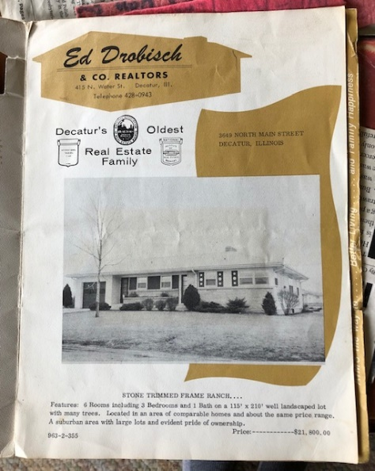 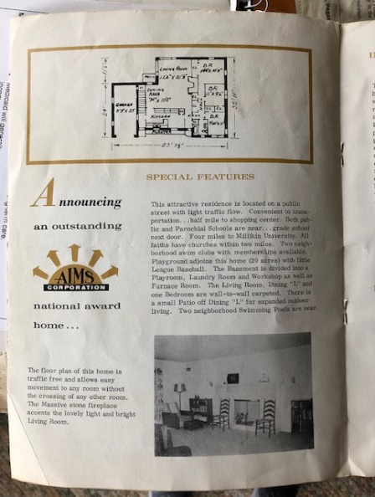 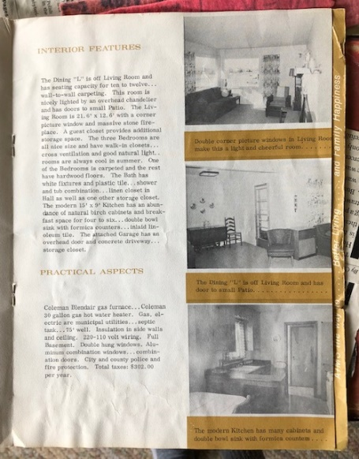

I stumbled on this brochure of the Decatur house when I was looking through old photos in Park Forest.

It was labeled in Grandmother’s handwriting. So thank you, Grandmother, for keeping *everything.*

We’ll be glad to get away from the slick floors here – somebody is always slipping and falling. The floors here are tile on concrete and very hard and slick. We bought a 3 x 5 throw rug for the living room.

This morning, after the people were here, we went and got new shoes for Alan. Lisa had new shoes just before we left Franklin Park and Lesle still had plenty of room. Afterwards we went on downtown (the shoe store is in the north part of town near a drug store and grocery store we trade at about a mile from the labs) where Ruth shopped at Carson Pirie Scott & Co (they have stores in Chicago). The manager of their shoe department lives next door and Ruth is real friendly with his wife. They have two children who play real well with ours.

Last Thurs evening we ate at a drive-in and then went grocery shopping. This week we’ll have to go to the library one evening. We went to the park for a picnic supper one evening last week. Afterwards we stopped at a Dairy Queen and Ruth did some shopping. It stormed last night and has been more seasonable the last few days. Last weekend we took a long ride around the lake and in areas where we had not been. It’s nice to be able to take a ride most anywhere in the area and not be more than about 20 minutes from home.

The only disagreeable things in this area are the occasional odors from the Staley (corn and soy bean products) Co. We get it more at the lab than here and it shouldn’t be bad at the other house. Our director of research (my boss) has been in Washington all week testifying before committees in regard to the patent question etc. on new drugs. He has testified previously about high drug prices. My work is going OK – I’ve run 20 dog experiments already and have some results so I guess I’ll have something to write up for my first monthly progress reports. We’ve played scrabble several times and I’m able to hold my own with Ruth pretty well (!).

We were glad to have Aunt Clara’s letter and yours also this past week. Dr. and Mrs. Clair Laidig, Ruth’s cousin in Seattle, recently had a new son, their first. He is the only child of Dr. Earl Laidig, the dentist in Danbury, Neb. We had supper with them when we were out there. I’m sure they’re thrilled.

We see the Valley Forge Headquarters of the American Baptist Convention when we drive the Penn Turnpike to Philadelphia. What will Mr. Hugel do at UCLA – teach and go to graduate school for a doctorate? Mr. Drobisch will give us $50 to help cover our move over to the other house. We can carry most of the small things in the car. Yes, I remember Ted Smith in high school. Its Irwin, Neisler & Co. Our total moving expenses were about $640 – much more than the estimate. Hope your all OK and tell Uncle Clyde hello.

**6-4-62 – 9:00 PM -** We were glad to have your note and clippings today and also had some clippings and a note from M.J. and Bill. They inferred they would like to come down before Bill starts summer school on the 18th. If they come before then we won’t be in our new house since the people are not sure when they’ll be out, but probably not before the 15th.

I left work early last Fri afternoon and we (a neighbor lady watched the children) went down to the mortgage company for the closing. We met Mr. Dahl (the people we bought from) for the first time. He has been working at his new job in Chicago since last fall and usually comes back on weekends. He is an engineer with Outboard Motors in Waukegan, Ill (a north suburb) and they are buying in Libertyville – one of the “wealthy” suburbs. After the closing they invited us out to the house for coffee. They have an engineer son 26, a boy just graduated from high school (one reason they wanted to stay through June 1st at least) and a younger boy and an older daughter. They showed us some of the things about the house and yard. They will pay us rent from the 1st till they leave at the rate of our monthly payments $149 (1st payment is due July 1st) and we will continue on here at $100 a month rent to Ed Drobisch the real estate man. The mortgage on the house here is being foreclosed – the people left with a very poor credit rating. We’re in no tremendous hurry to move over since it will give us a little more time to get some money ahead. I still owe some money on my Chicago salary repayment but I have yet to receive my Atlantic City travel money which will cover part of it.

Last Fri night Ruth kept some children (in return for the afternoon sitting) so some neighbors could go to commencement to see some relatives graduate. Sat morning we took our time getting around and then went grocery shopping. We stayed home in the afternoon. I worked some in the evening while Ruth went to a neighbors. Sun morning we all went to church. We’ll join the Westminster Presbyterian which is the one closest to the university. We’ll be welcomed next Sun.

Sun afternoon we stayed at home. I wrote up my monthly progress report for May. Everybody writes one and the results are discussed at a monthly meeting. Sun night we went for ice-cream. This morning Ruth and the children took me to work so Ruth could take Lesle to Bible School. Lesle has promised she’ll play and sing with the other children. She is quite independent and often doesn’t want to be told what to do by a group leader. The Bible School runs for 2 weeks.

Well, a year ago tonight at this time I was about ready to walk across the platform at commencement in Lawrence. I never did buy the “hood” like I said I might. Hugh Burford, the 3rd graduate in pharmacology (I was 2nd) should be graduating tonight. This Wed night we may all go to a drive-in movie and Thurs night an insurance man will be out. A wk ago Sun we all went to church. Thurs night we went out for our anniversary dinner (we hired a baby sitter from church) and just rode around awhile afterwards.

No, we didn’t hear about your storm but it may have on a news broadcast we missed. It sure sounded bad. Our insurance on the new house (to cover fire, damage etc.) costs about $62 a year. We have had a lot of thunderstorms here. Analexin is a drug that is analgesic (like aspirin) and muscle relaxant. It could be used in arthritus. It is a result of “our” research program and has been on the market several years. I don’t know the name of the potassium iodide preparation but could look it up. It may be called Day-nite and is used for asthma. Here’s hoping you’re all OK. The children have been well but Alan is quite irritable from cutting some new teeth.

**6-19-62 – Tues 9:30 PM -** I’ll splurge and use some of the company stationery. We all just got back from the Neisler picnic. It was a perfect evening, a little bit cooler than it has been. The employees were allowed off at 2:00 PM but I ran my dog till 3:00 since I knew we wouldn’t get around anyway. We stopped by the library on the way to the park. (There will be a branch library near our other house and I’m even reading one of the religious books that Ruth checked out.) The picnic was in Nelson Park which is the one by the lake. The kids played awhile and we all took a boat ride (paid for by the company) before eating at 6:00. There was some entertainment. Ruth got to meet the fellows at the lab and we both got to meet some of the wives and children. Of course, I didn’t know a lot of the ones from the plant downtown. I haven’t been in the plant yet, but we have driven by; it is not too large a building. Alan didn’t eat much supper as there were too many people around.

Last evening we went over to the house and picked some raspberries off our own bushes. We’ve been over several times and have also had some cherries from the cherry tree. Ruth has made 2 cherry pies. The Dahls have had a lot too. The packers are coming next Mon for their things so it looks like we’ll be moving the middle and last of next week. We’re certainly ready to get out of this house now. Ruth has already planted some things over there and has some more things ready to set out. Our first payment (of 30 years ha!) comes due on the 1st. I think I told you the total payment is $149 which is only $9 more than we were paying for rent in Franklin Park. We payed Mr. L a $100 already.

We were so tired last evening we went to bed early. I think we’ve had touches of a cold. We didn’t feel perky on Sun so missed church. You know we have to be pretty tired to miss church. John Laidig wrote they would stop by here overnight on their way back to New Jersey, about July 12th. I believe Mrs. L wrote that Grandmother is getting more confused all the time and falls quite often. Its good we had a good visit with her when we were out there. Mrs. L’s sister Aunt Lenore from Miami may get up awhile to relieve her. If she does they will probably try to get back and see us a few days. Why don’t you plan on coming sometime after we’re settled, which shouldn’t take us very long. We haven’t heard from M.J. and Bill so don’t know when the’ll try to get down.

Last Sat morning I went for a life insurance physical and Ruth went shopping in the afternoon. We’ll probably hear from you tomorrow. Hope you had a nice birthday. I read all the clippings Sun. If we would have a hail storm our car would sure get hit here. We went to the library last Thurs evening. Lesle went to Bible School every morning last week and they had a picnic last Fri morning. Sun afternoon Dr. Bill Stone and family stopped by. He is a new intern from the U of Ill and will be at the local hospital this year. I knew him at the labs there. Here’s hoping you’re all OK. Happy birthday to Aunt Clara since she’ll get this before a card.

**7-5-62 – Thurs 10:30 PM –** We were glad to have your letter earlier this week and to hear the news. We still haven’t heard from M.J. and Bill. This evening I was late getting home from work so we were late getting over to the house. We take a few things every time we go over. We had thought we’d get all moved this weekend but it doesn’t look like we’ll make it now. Several fellows have offered to help if I want to rent a truck etc. However, I’m not so sure but what it would be better to just hire it done. The real estate man had allowed us $50 for moving. I’ll also owe him rent for June here.

I finally received my $150 travel money for the trip to Atlantic City so I’ve paid back all I owe to the U of Ill. We may try to get back to Chicago for a day sometime later this summer. With everything that is to be done at the house we’re not going to have much time for anything. After going by the house first, this evening we stopped by at a new supermarket (A & P) in the Brettwood Shopping Center which is the new one a mile south of our new house and the closest shopping. Not all the stores are finished. We came on home, gave the kids baths,



Picture taken in December 1961

and Ruth has gone on back to do some more work. Its 3 miles one way and 4 miles another from here to there. Today was about our hottest day and this house gets pretty uncomfortable for Ruth during the day. It often clouds up but we haven’t really had any rain for some time. The yard is quite dry over at the other house so we water every time we go over. It is a well which supposedly is pretty good. We are still having raspberries off the bushes. Ruth has planted some flowers and vegetables and we had some flowers from some that were already blooming. The house is surrounded by bushes and shrubbery on about 3 sides.

The Dahls moved out Tues. They paid us rent for the time from June 1st on. They are renting temporarily until they can get into their house (in Chicago suburb). Yesterday and tomorrow mornings a neighbor lady is keeping the kids so Ruth can go over and work. Tues night we hired a babysitter so we could work a little later. There is no gas in the kitchen (just electricity) so it will have to be piped about 10 feet for our stove. I paid the Dahls $10 for there power mower which, if it lasts through this year, will be worth it. Alan is into everything and only minds some of the time. He is saying a lot of new words now.

My work is going fine. My 1st report was OK. Dr. Tom O’Dell, the other one who is trained in pharmacology but who has to do a lot of non-pharmacological work, he is director of the biological side, is in the hospital after having an emergency operation for a perforated intestine. I guess he caught it just in time. Dr. Alan Gray, the director of the chemistry side, is on vacation.

We all went to church last Sun. Lisa got to come in big church and she was real good. The’re OK when they don’t go in together. Ruth has dyed our pink bedspread a dark green. She has painted the girls room over at the new house a light green. There is some more painting that needs to be done. Mrs. L’s sister will come from Florida but she didn’t promise that they would get here soon. She’s just like you and Aunt Clara about Uncle Clyde feels like she needs to stay there with her Mother. We have birthday presents for you both and will get them off soon. John Laidig will be here later July 12th. Some of the wheat is up around here and the corn. Alan loves the horses we see when we drive over to the house. I got 2 new shirts and tie for Father’s Day. Was it Norman Hogues that had the baby boy? They have a new student pastor at Westminster in Lawrence. You can send the clipping to M.J. The picture was taken with a camera in the hall by my lab with no extra lighting. The coat was borrowed.

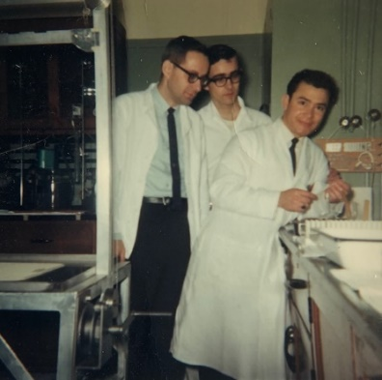

This may be the picture Dad is talking about.

Pete Luna is on the right. Unidentified man in the middle.

I got the mortgage insurance so that gives me $53,000 life insurance which should be adequate for quite some time. I read Jesus of Nazareth – The Hidden Years – by a Jew and about the time before Jesus’s ministry. Things grow pretty well here. There are errors in here uncorrected.

**7-11-62 – Wed -** I know you’ve been waiting patiently to hear from us and I have no real excuse except that we have been fairly busy with the moving etc. (sounds like a good excuse to me ☺) We were glad to have your letter yesterday.

Sun – 10:45 - This has been a hectic day. We were ready to go to church this morning when the car wouldn’t start. I just got back now from having a new battery put in. I knew I needed one and it finally had given out. Ruth had trouble one morning with the car and had to have a new starter switch put in ($8 including a tow in). So we have had some car expenses but no major breakdowns yet. I’d like to keep the car at least another 2 years if it holds up and go ahead with some things on the house.

We had “church” at home this morning. We had rushed around getting ready as we were late getting up. This afternoon we worked in the yard while the kids took naps and then I finished putting up the swing set we bought. It has a glider, 2 swings (1 baby seat for Alan) and a lawn swing where 4 children can sit. We set it right beyond the patio to the West so we can watch them from the kitchen and living room.

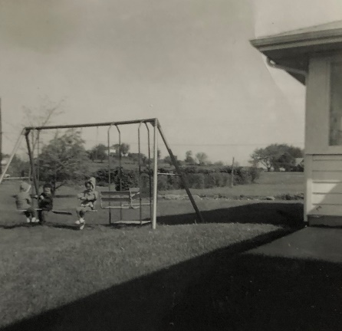 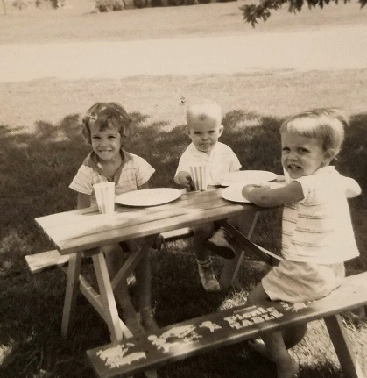 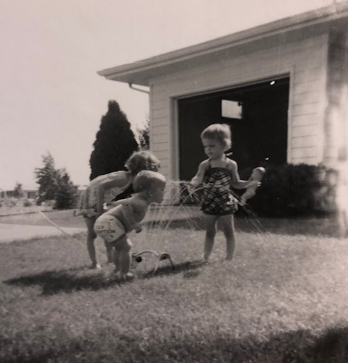

Summertime in Decatur. The picnic table is the one they bought in Franklin Park.

We may get a swimming pool as our old one is all worn out and that will take care of the kids for the summer. Another year we might get some kind of a sand pile. They track in so much sand and it would be hard on the carpet. I guess we’ll have to get a new sweeper for this good carpeting since our old tank type is worn and just won’t clean a heavy carpet. (Its one Mrs. L gave us and is almost 20 years old). We’re considering a dehumidifier for the basement to protect things. Some of my books were already starting to mildew in the last 2 months. We’ll have a lot of initial expenses but things will ease off then. We still have a lot of sorting and straightening up to do but can take our time now that the big things are in order. Ruth will have to make some living room curtains as Mrs. Dahl wants the present ones back. She is making kitchen curtains also.

We had things in pretty good shape when the John Laidigs got in about 7:30 Fri night. They were tired but stayed up awhile to visit and then all slept in their tent. We had plenty of room for it. They should just about be getting home this evening in Chatham, NJ. We had already eaten supper when they arrived so they had more room in the kitchen than if we’d tried to eat with them. They had breakfast yesterday morning with us and got away by 9:30. We “collapsed” after that as we had rushed to get things in order. Both you and the Laidigs don’t feel they can come right now so I don’t know who our next relative guests will be. We should be pretty well fixed up by the time M.J. and Bill come by.

My work is fine. We got a new $3500 instrument which I will use to record blood pressure etc. and which is an improvement over our present method. It is not as fancy as some places have but is good for us. I turned in my June progress report last Mon, and this Wed morning I have to give a 2 hr lecture to the new group of salesmen (12) on general pharmacology. Once a year they bring the new salesmen in for a 2 wks training course. I’m, of course, working on thru the vacation period the last 2 wks of July. The period mainly affects the manufacturing which shuts down completely.

We still have 2 birthday gifts for you and Aunt Clara. The Presbyterian School Millikin U is here; I don’t know whether Dr. Mallett went there or not. We heard (for Aunt Clara) Dr. Logan at 1st Presby but joined Westminster.

Our schedule since I last wrote was to just move things gradually over here after the Dahls left. Ruth came over many days to paint and either hired a babysitter or left them with neighbors. A wk ago Sat we rented a trailer and 2 other fellows and I moved everything but the piano. (We’ll have it tuned now). Its been moved about 8 times now and still looks fine. They brought the piano on Wed and we finished cleaning over there Wed night. Ruth returned after I called you. He charged us $200 rent for the total time – about 2½ months so that wasn’t bad. We been downtown shopping and to the library several times and that’s about it. Alan won’t stay away from the records and is quite a mischief. Here’s hoping you’re all OK and sorry I’m late.

**7-24-62 – Tues –** We were glad to have your letter today and to hear about your doings. We had just been thinking about the Lesters and were glad to hear that they had made it OK to Denver. We now both have several friends and relatives in Denver and could make quite a trip there sometime just to visit them. Deloris Musgrave (the one who was a freshman at Fort Hayes) has been there some this summer (she had quit her job the last we heard). David Musgrave (he’s the one who went to the military school in Salina and then went a year to Kansas Wesleyan) is working in Denver and Dallas Musgrave was there some we understand. Dallas is the one who was in Chicago and the one who got married in Minneapolis, Minn when we went to the wedding. The last we heard they were separated. In Chicago, we hired a babysitter and made a special trip downtown to see about a will etc. with the lawyer for whom Carol (Dallas’s wife) worked. She delayed it some way (?) and we never heard any more about it. We assume she’s still in Chicago.

Danny Musgrave has a job in Oberlin this summer. I guess Ted Addleman got a relief pharmacist so he could take his vacation. I was too early this year to help him. I have my notice for renewal of my Kansas pharmacist registration. I suppose I’ll continue to keep it up since if I drop it they might give me trouble on a renewal if I ever wanted it. I didn’t miss the drugstore this summer since I have plenty of chance now, being in the pharmaceutical industry, to keep up with the new drugs, etc. which is something I always did in the drug store.

My lecture on general pharmacology last Wed to the new salesmen went OK. It was about 1½ hrs. There were 12 new salesmen from all parts of the country and they meet for a 2 wks training session. They said (the salesmen) they enjoyed it. They try to cram in a lot of information in 2 weeks and are somewhat overwhelmed. I ate lunch with them and then Glen Miles showed me around the plant since I had never been there. Glen is in the advertising end and lives not too far from us.

This week and next is the regular plant vacation period. 2 or 3 of the animal room boys are still there so I can still get animals for my work. There are several others there who took their vacations early or who will go later. I’ve been splitting rides with another fellow who lives out this way.

My work is going OK; there is no end to research, as you know. Neisler has plenty of new chemicals to work with. Dr. Tom O’Dell (director of biological work) who had the operation is now back at work half days. We all went over to visit them last Fri night. They have 3 girls, the oldest 16. He’s about 41-43. His wife has some kind of back trouble. He has a degree in pharmacology from Minnesota (same place as Dr. Peters) but hasn’t had time to pursue the type of research that I’m doing.

Today has been quite a bit cooler. We really haven’t had a bad summer, so far, although it gets quite humid here. Our basement is finally getting dried out. We bought a dehumidifier ($83) a week ago tonight and have had it going continuously. This last week-end we got the rest of the boxes unpacked so our next job in the basement is to clean it up and get the rugs (the ones we’ve had in our former living rooms) unrolled and into position. The Dahls left an old double mattress so we can sleep 4 people on our extra mattresses.

Our pump works OK (we’re not on city water) the Dahls decided not to hook up when they laid the pipe out front. We have a septic tank; the sewer also runs out front so if we ever need to hook on for either one we can easily do it – for a price of course. Since they didn’t hook on we are just outside the city limits; since we’re outside we had to pay $7 to get a library card (we went last Sat morning). There is a small branch library near here which we haven’t been to yet.

Last Sat morning we also bought ($77) the living room curtain material; we have to return the Dahl’s curtains. Ruth is working on the kitchen curtains. This morning the Hoover man was out and we bought ($75) a new upright Hoover vacuum cleaner (on credit), so you can see we’re about broke but these were more or less necessities. I can remember playing most of the band numbers that Eli Farney liked. I imagine Leroy Esau will try to continue the band, even with his new school job. I played in a trumpet trio with Leroy a few times.

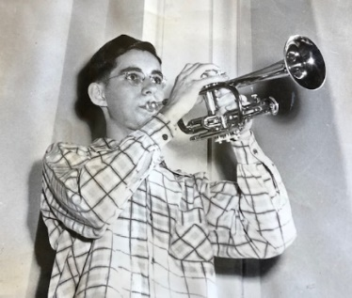

The youthful musician.

Last night I sprayed the raspberry bushes and fruit trees and evergreens for bag worms and insects. We should have sprayed earlier but just didn’t get to it. I need to spray for weeds now. There is a lot of crabgrass, they have sprays for it, but I may let it go awhile. (Silent Spring was published in 1962 ☺) I pruned the raspberry bushes before spraying. Ruth is weeding the garden and flowers; she has planted a lot of things. Anyway we’re enjoying everything despite the extra work.

Tonight we all went up and watched the junior baseball league game awhile. Later I put some new covers on your old lawn chairs. Grandmother is in a coma part of the time so the Laidigs won’t get away now. Aunt Lenore is still there. I’m not sure of our roof – I don’t think the’re wooden. The house is white. Faces East. The patio is cement. The screens are aluminum. I think flowers grow pretty well. Bluegrass. Glad to here you’re getting the house fixed up. Hope you’re all OK.

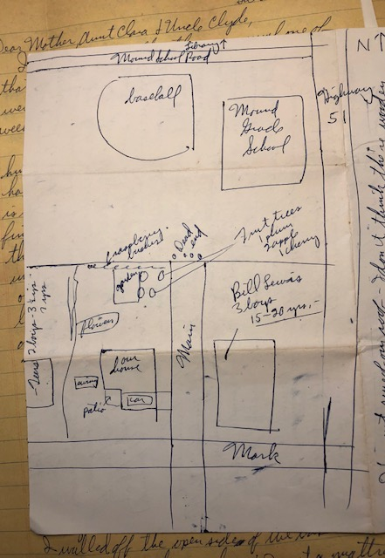

Dad includes a drawing of the immediate neighborhood.

**8-4-62 – Sat 9:30 PM -** I have no excuse, other than our usual one of that we’ve been busy, for not writing sooner. We were glad to have your usual letter this past week. The last few days have been warmer and more humid after one of the coolest Julys they’ve ever had. The dehumidifier runs most of the time and is keeping the basement dry. Last weekend I finished unpacking the rest of the basement things; the girls had a lot of toys etc. I unrolled both of our old rugs for the kids to play on. We have a chain lock on the door into the laundry half of the basement so Alan won’t get over there and fall in. That side is partitioned off now and has the door, but we may change it around someday. Many memories of playing in this basement. The laundry room with the sump pump was always off limits and scary. Dad had his magic in the locked room too, with the floating lady contraption set up in the back I think. In my memory the partition between the two rooms was just boards leaning on each other, forming an ‘A’ shaped tunnel in between. Lesle and I played in this tunnel a lot. We may have had a cardboard toilet in there. Which we used on occasion. I don’t know why. We may have gotten in big trouble for it.

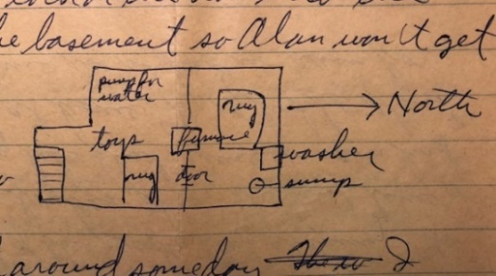

I can’t get the water softener open to recharge it so I’ll have to work on it one of these days. Our water is quite hard and we’re getting rust streaks (like you used to have) in the sinks and tub. Last Sun I walled off the open sides of the basement steps so Alan can go down alone. I put a mattress at the bottom in case he falls. Alan’s words are becoming more clear all the time and his sentence jabber is quite funny.

I’m staying ahead in the yard although the dandelions are coming back. I’ll spray one of these days. The weeds got ahead in the garden and ruined some of the flowers and vegetables that Ruth planted earlier before we moved over. I just finished pulling the last of the weeds this evening. I trimmed 3 of our bushes also – the first time I ever did something like that since we never had any bushes there at home. We’ve had to start watering again since we’ve had no rain for some time.

I washed the car this evening and will polish it sometime. I had to replace the battery generator and something else recently – over $50 worth but otherwise it seems in good shape. We all made it to church last Sun – it was Lesle’s turn to go in big church. I won’t be trading any more rides, at least regularly, with that other fellow since vacation is now over at the lab and he’ll be back trading with the other fellows. Work is going OK.

Thurs night we took the kids to the Macon County Fair. They saw some pigs, cows and rabbits and all rode on real ponies. This past week we mailed the living room curtains to the Dahls and Ruth started on the new ones. They are plain creamy off white and red ball fringe at the top. The lamp shades will have some ball fringe also. Ruth is using the zig-zagger attachment on the sewing machine (I got her for Christmas) to do the blind stitching. Also this week Ruth started removing the old varnish and painting in Alan’s room. I put on the 1st ceiling coat this morning. The color is Caribbean blue with red and white striped window shades.

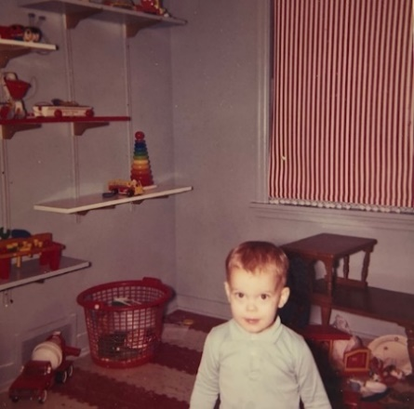

Alan in his finished room – January 1963

The Rev. Moyes family (Kans. City pastor) will be stopping here overnight on Mon or Tues - so we’re trying to get Alan’s room done before. M.J. wrote they would be here the 24th I believe.

Last night Ruth visited her friends over near the other house. Tell Uncle Clyde that the girls said at the supper table that they want to go to Uncle Clyde’s house and Lesle cried when we said we couldn’t go till next year. They remember going over there and she remembers the broken television’s (?) and the building. Sorry to hear about Uncle John. I’m glad we made the effort to visit them. Grandmother Williams is in the hospital and is getting weaker. Glad you rented the apartment; that’s the one we were in you know. Dallas M. now has a job in Denver and is just separated, I guess. Don’t work too hard in the hot weather.

**8-14-62 – Tues –** We were glad to have your letter today and to hear all the news. Our weather has been quite pleasant again recently. We haven’t had any 100 degree days and only a reasonable number in the 90’s. It does get quite humid, however, at which time we run the dehumidifier.

Ruth goes to the New Towners Club this evening. That is the group of women who have been in town less than a year. She has been to 1 or 2 of their other meetings. I took my lunch today as Mrs. Ratliff (about Ruth’s age) and her 2 children came over this morning and stayed till about 1:00 PM. They live over by the other house which I guess hasn’t been rented or sold, as yet. Ruth went over and visited her last Sat night.

Rev. Moyes and family from Kansas City got here a week ago yesterday evening. They had stopped at New Salem to see Lincoln’s home. (We may go visit it sometime.) They stayed all night. We brought mattresses up for their children. Mr. and Mrs. Moyes used our bed and we slept in Alan’s room. They left Tues morning to drive on to Chicago and then a camp in Northern Wis not too far from 3 Lakes.

Sorry to hear about Aunt Nellie. You remember we thought we’d get up there before we left Franklin Park but just didn’t make it. Aunt Lenore (Mrs. L’s sister from Miami) was here Fri on her way from Oberlin to reunions in Indiana and then on home. She stayed with Grandmother for awhile. They had a chance to rent Grandmother’s house (it is owned by the Laidigs and is next door South) so went ahead since they feel she’ll never be home from the hospital. She is quite confused most of the time. She is 95 and if she lives to Sept 4th will be 96. We’re glad we had a good visit with her when we were there and got some pictures. She was still getting around some then.

Uncle Edgar (Mrs. L’s brother at Norton and farmer) and Aunt Dova came through Sat on their way to the reunions. They couldn’t stay for supper as were late. The reunions were Sun. Grandmother used to always go back – Mrs. L would take her. Mrs. L has had a bad spell of labyrinthitis - infection in the ear which makes her dizzy. Her birthday was yesterday and Ruth called her since we didn’t have a gift off. She said Mr. L was at a school board meeting in Atwood. You may remember that he will be grade school principal this next year there while the regular man is gone.

Sat I put up some pegboards in the kitchen for Ruth to hang up plants and copper molds and measuring spoons. It adds décor. Fri night we all went downtown and bought solid Maple bunk beds for the girls. Lesle up, of course. Alan had outgrown his collapsible baby bed so we set up, with all sides, Lisa’s bed for him and will leave Lesle’s up until after Jimmy has been here. These beds can become twin beds and should last the girls until they’re married ha! or gone from home. And so they did, or at least mine did, not sure what happened to Lesle’s after she got her built-in bed. They are best quality and fit in nicely.

Sun we finished painting Alan’s room. I finished the white ceiling – had to go over it 3 times as the paint spread too thinly the 1st time with a brush. Ruth finished the blue walls; it took her all afternoon. The bright red and white striped shades give a nice contrast. The kids rooms are now complete except for some drawer shelves which will hook onto the wall. We’ll start refinishing the living room after M.J. and Bill are here, and our bedroom will come last. Yes, our yard would be larger than Bill’s. I’ve enjoyed the yard work – works off some of energy. Hope you can come sometime.

**8-26-62 – Sun 5:00 PM -** I thought this week I’d get back on a more nearly weekly letter writing schedule but various things have come up. Today started off cloudy but is now clear and warm. Yesterday when the folks were here was cool and rainy. We’re about ready to eat supper and we’ll all go down and mail this after awhile. We missed church today as we were pretty tired from everything and Lisa and Alan have runny noses. Alan’s may be partly from a new tooth. I took advantage of being at home and worked on some research records. This coming week, in the evenings, I’ll have to write my progress report for July and Aug. Because of the vacation period we didn’t have to turn in a progress report for June. My work is still going fine.

Ruth did some sewing this morning. We now have the kitchen curtains up – café style. The kitchen shades will be covered with cloth. She recently made some cute summer outfits for the girls and completed an outfit for herself the night before we went to Indiana. This Tues night Ruth will go out with a beginners bridge group; its a group from the New Towners Club group – women who have lived here less than a year. It seems like everybody in Decatur plays bridge so I may have to learn. However, I’ve never cared too much for card games but, of course, I like card tricks.

We all made it to church last Sun morning and Mrs. L called just as we got home to say that Grandmother had passed away that morning at 7:00. It, of course, was not unexpected since she had been pretty much down the last month or so and her mind wasn’t too clear. She had felt her usefulness was gone for quite some time since she couldn’t see to read and couldn’t do the sewing she used to. She made hope chest quilts for all her great grandchildren (and for Ruth, also). Lesle’s quilt was finished soon after she was born. Mrs. L brought it with the enclosed note when she came through. Lisa’s quilt was only partly finished before she couldn’t see enough to finish it.

I was ready to write you last Tues night when Bill and Florence Stone called and said they would be by after going swimming. He is about my age and is an intern at one of the local hospitals. They have 3 children. I met him in Chicago, he worked for someone there where I did and graduated from medical school there last year. He started his internship this summer and after finishing next summer will go into general practice. They are Unitarian. One of the friendliest fellows at the lab is a Mormon. He doesn’t even drink coffee.

Wed night I was pretty tired and Ruth stayed up late to finish her dress. Mr. and Mrs. L drove through Wed afternoon and went on to Indiana. They brought us a lamp and chair of Grandmother’s and some of our wedding presents that had been stored in Oberlin. Thurs morning we got the house straightened up and left about 11:00. The children stayed with Dutch Ratliff (the lady over by where we used to live). Ruth brought her a present to “pay” for the childcare. 15 mins after we left Lisa fell out of their swing and cut her mouth. Dutch took her to a Dr. and he cleaned it. Sat morning we took her back for a checkup. Wed night we’ll all go back, have Lisa checked, and all get polio shots. The Dr. bills will be covered by their insurance. We got to Rockville, Ind (17 miles inside on highway 36 – about 100 miles from here) about 1:00. We ate downtown (town about like Oberlin). The funeral was at the country church near the farm where they lived and where Mrs. L was born.

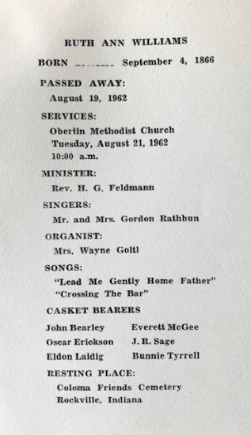

The program from Great Grandmother’s funeral.

They lived 1 or 2 other places before eventually moving to Kansas. It was hot and I met some of the relatives. The cemetary is by the church. It is pretty and hilly around there and they have lots of covered bridges. We may go back this fall. We left about 5:00 after eating something at one of the Aunts. We got there too late for their dinner. The Laidigs came back here after we did, we got home about 7:00 and they got here about 8:00. They brought Uncle Edgar (the brother at Norton) and Aunt Dova (his wife) and they went to a motel. They went back on the train but had driven back earlier to the reunion. We went out to eat after the Laidigs got here (had a babysitter over) and I took them by to see the labs. They left early Fri morning and Mr. L called yesterday to say they had made it OK by that evening. He’s working for the Atwood schools now. Mrs. L will probably come back for a longer visit this fall.

Fri night I went down and picked up the drawers and shelves to hang on the walls in the kids rooms. They will have to be painted first. The shelves we ordered for the bathroom have come. They are spice cabinets and will increase storage room. M.J. and Bill finally got here (held up by rain) and we ate. She probably told you what we did. I showed them the lab etc. We were so glad they could stay as long as they did. Our refrigerator door latch is broken and the part has been ordered. Glad to have your last letter. Hope it hasn’t been too hot. You seem to always have plenty to do. We recalled that Deloris Harbaugh didn’t think the young people cared too much for Lauren Hedeen. Hope you Aunt Clara and Uncle Clyde are all OK.

**9-13-62 – Thurs 5:30 PM –** We were glad to have your letter on Tues and to hear the latest. They have 2 state fairs in Ill just like Kansas. I don’t know whether they are both official or not. One is at Springfield and the one at Duquoin.

This has been one of our hardest weeks. Last Fri Ruth took Alan to the Dr. for his eye infection and the ointment seemed to clear it right up. However, he thought it best that he not go to church. Therefore, Ruth stayed home with him and made a birthday cake for Lisa while I took the girls to s.s. I sang in the choir and began getting quite a headache and feeling pretty tired during church. I thought it was just the fact it was my first time in the choir, until later in the day when I began getting a fever, and got clear down, apparently with a virus. After taking a lot of aspirin I felt good enough to eat some of Lisa’s birthday supper and watch her open her gifts. Unfortunately, the camera wouldn’t work. She got several new wooden puzzles and gave one each to Alan and Lesle. Grammy and Grandpa sent some red knit pants and you sent the nice dress and book, thanks. We gave her a big set of kitchen utensils, a windup teddy bear that plays Brahms Lullaby, and a stove with a real door, knobs, etc. Her party has been postponed till next Mon so she’ll get some more things then.

I’ve stayed home from work all week but will try to get over some tomorrow. My fever stayed down pretty well yesterday and I finally felt like doing some reading. It has been hot the last few days which hasn’t helped. This must be about the longest stretch I’ve been down since I left home to go to college. It definitely is the longest I’ve been down since we’ve been married. Ruth felt OK, fortunately, while I felt the worst, so the kids got taken care of. However, by Tues afternoon she was feeling like I did at first, and Tues evening the kids didn’t get much attention. She had some fever and got a sore throat like I did but I don’t believe had it quite as bad ha! We’ve been up and around and dressed today, but are still tired and have some sore throat.

Dr. O’Dell says the fellow at the lab who brings me my animals also got sick so I guess one of us gave it to the other. I don’t know whether it had any connection or not with the fact that I used, for the first time, some cats last week and he brought them to me. I suppose they can harbor some viruses etc. that humans can get.

Lisa and Alan have runny noses today and feel more tired and irritable so I guess they have caught some of it. With the little ones to take care of it’s almost impossible to isolate yourself from them. Well I guess our sick news is about it for this week. We’ll get out to a drive-in for dessert after a bit and I’ll mail this. I can’t find your letter now to answer any questions. Were Uncle John and Aunt Faye back in the hospital at Wichita or had they made it to Tulsa. Glad we stopped to see them and Uncle Archie. Hope you are working something out for Uncle Clyde that will be for the best.

**9-20-62 – Thurs 9:45 PM –** We were glad to have your call last Sun. I always figure the calls are worth it. An insurance man was here this evening or I might have taken this down to the post office. I’ll mail it at the lab in the morning but you may not get it by Sat.

Last night and tonight are much colder and it really feels like fall. I’m glad for the garage; I’ve always had trouble starting the car in the winter, you know. I’ll need to get the car in for fresh anti-freeze before long. Ruth went to choir practice last night and I stayed with the kids. We both still have slight coughs and I knew I couldn’t sing without coughing. Ruth said she couldn’t sing above a certain level without coughing. We’ll both try to sing this Sun, I guess.

This Sat Ruth wants to go to an art show at the art museum associated with Milliken University. Ruth used to enjoy painting so I guess I’ll get her some painting equipment sometime. I guess Milikan University isn’t much bigger (1200 students) than Hutchinson Jr. College. Several Milikan students are in the choir. A week from this weekend we’re planning to go to Chicago and visit our friends. Sometime we’ll try to go to St. Louis. I suppose we could go meet anyone who would get as far as St. Louis. There is 4 lane highway most of the way and I suppose a 3-4 hour drive.

Our throats and ears are much better but, as I said, we still have “ticklish” throats. Lisa and Alan still have runny noses, somewhat, but Lesle has had only a touch, she is generally the most resistant to infection. I guess I didn’t get from the cats; there has been quite a bit around. We’re actually in the far North part of town but we were more Northeast. I expect the hepatitis trouble was in a “poorer” section. We could hook on to the city water but it would be quite expensive.

Hope you get something worked out for Uncle Clyde – no, I don’t think thats selfish when he’s obviously senile, you’re really not able to completely care for him, and its for his good physically and mentally. Senile deterioration is usually, at least partially, due to hardening of the brain arteries and that is irreversible, although psychiatric help might benefit some. I don’t know how violent such people can get.

I mowed the yard last Fri night and Sat morning. It was getting quite high as I had planned to mow when I was sick. We’ve had quite a few flowers that Ruth planted as we were moving over and Ruth picked a lot of them tonight as it may freeze.

We stayed home last Sun and went through a lot of things in our bedroom and did some cleaning. The refrigerator is a Frigidaire, is turquoise, and never accumulates any frost.

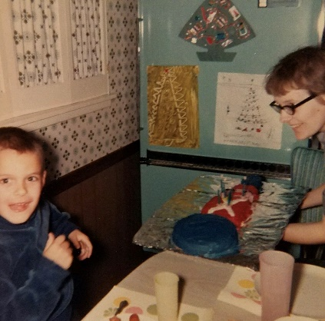

The turquoise refrigerator still going strong a few years later in Park Forest.

We definitely will need a bureau for our bedroom as we don’t have enough drawer space. Aunt Clara shouldn’t have to drive to Wichita so I think he’ll just not be able to go back to Wichita, especially since Aunt Faye and Uncle John are now gone. Tell MJ and Bill hello and hope you’re all OK.

**9-28-62 – Fri AM -** Thanks to everyone for the cards, letters and gifts. I’ve worn the tie several times already. Lisa says “thank you” for the dress which she has already worn.

Last Sat morning we went to the art show; not too many good pictures but we bought one for the girls room and had the kids faces done in charcoal by some lady.

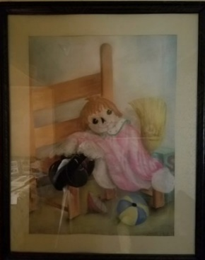 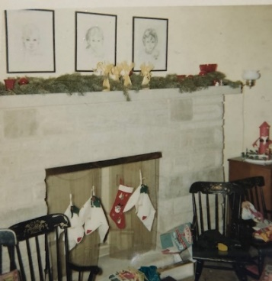

The artwork acquired that day. My charcoal face is now sitting on the bookcase in my office, sans the glass.

Sat afternoon they delivered an Ethan Allan chest on chest for the bedroom. It was my idea that we go ahead and get it since we desperately needed drawer space in the bedroom and we’ve never had anything but our dresser. This is all the buying for some time until we get them paid off.

Sat afternoon Ruth and the girls went for haircuts. Ruth has always cut her own (I’ve done it sometimes (?!)) and the girls, so I said they deserved a professional job.

Sun we all went to s.s. and church. We got along singing without coughing. Had 9 basses so it’s a much bigger choir than we’ve sung in for some time. I had a nice birthday dinner and one of the fellows at work (his birthday was the 21st) came over for dessert. I got 2 shirts and 2 socks, besides yours, from the kids, and Ruth got me a foot rest (wooden and like an odd shaped little rocking chair) for use with the big rocker.

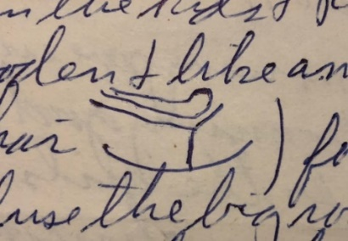 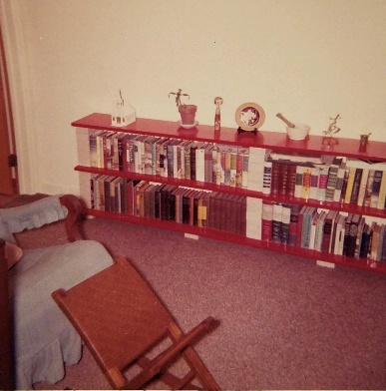

Dad’s drawing, and the real thing.

Also the much discussed brick and board bookcase, the ‘Jap-plate’ on display, and the newly slipcovered rocker.

This is the rocker that I hid behind after accidentally flushing Alan’s diaper down the toilet.

I’ll use the big rocker more, now. Mon night we went downtown to leave the kids pictures for framing, and Tues night was the Neisler fall weiner roast; it was held in a building. The kids wore themselves out and we stopped by a lab fellows place afterwards. Ruth went to choir Wed night. Tonight we’ll drive part ways to Chicago and stay in motel. We’ll be at Bob Gerdings in Franklin Park sometime Sat (Next to our house there) and also visit Jack Duvalls in Bensenville where we’ll stay all night Sat, I guess.

**10-17-62 – Wed 9:30 PM –** We were glad to have your letter today and to hear all the details. As you say, things have seemed to work out for the best. It was most fortunate that M.J. and Bill were back in Kansas so they could be of help.

The last couple of days have been quite warm and with the air-conditioner off at work it has been uncomfortable. I got my Sept progress report in today; there was no hurry this month since Dr. Cavallito (Director) has been in Europe the past 2 wks and won’t be back until sometime next week. I went to choir practice alone tonight and Ruth stayed with the kids; our babysitter had a cold and Ruth had been out the last two nights.

Ruth’s Mother is supposed to get here sometime tomorrow. She left Oberlin alone Mon and was going to take her time driving through Southern Kansas, the Ozarks and then on here. The plan is that we may all go over to the Covered Bridge Festival at Rockville, Indiana (where we went for the funeral, about 100 miles) (James Hudson house there) leaving here either Fri after work or early Sat morning. We would come back Sat night.

Last night we voted on a school referendum. The school board was asking for money to build 3 new jr high schools. One of them would be built on the vacant land just North of us. However, the bond issue was defeated, so we won’t have the school next to us for some time. The vacant land is owned by the school system and is right behind the present Mound Grade School. After voting I took Ruth downtown to a Newcomers Club dinner and fashion show. Afterwards the kids and I stopped at the drive-in for supper.

Mon night Ruth babysat for one of the friends over by where we used to live. I softened the water Mon evening for the 2nd time. I softened it first on Labor day. Last Sun I stayed home with Alan since he had a runny nose while Ruth and the girls went to church. In the afternoon we went to an AAUW sponsored antique show. We had a babysitter. We bought ($2) an unusual type of little druggest scales. Ruth joined the AAUW. They have several interesting study groups: music, art, creative writing etc. Sun, late, I mowed part of the yard.

Last Sat morning I went to the bank and got salt for the softener and anti-freeze. Sat afternoon I took the car in for some work. I had to take it back Mon. Fortunately the car held up, without any major expenses, until we got here. Sat afternoon we went down to register to vote. Last Tues night Ruth went to the League of Women Voters (they were opposed to the school referendum). Wed night we both went to choir practice. Thurs night Ruth was going to AAUW but had some cold so she stayed home.

A week ago Fri night we left about 6:00 and drove to a motel about 80 miles from Chicago. Sat morning we drove on into Chicago and saw the Gerdings and our former neighbors. We had lunch with the Gerdings. Later in the afternoon we visited Bruce and Carol Ferguson (at church there) and then went on out to Carol and Jack Duvalls where we had supper and stayed all night. Sun morning the children all went to s.s. We had lunch and left for home about 2:00. Stopped at Bloomington for supper on the way. I haven’t answered any questions you may have asked. Here’s hoping you are all getting rested up and are OK. Let Aunt Clara and M.J. and Bill read this if they want to.

**10-21-62 – Sun 4:30 PM** – I’m writing this from the hospital where Ruth has been since late yesterday afternoon. Yesterday morning she bumped her head on the fireplace mantle. She developed a severe headache later and reacted quite strongly like she has in the past with pain so we had the Dr. and he thought she better come to the hospital so she could be watched just in case. She is feeling better today and if the x-rays they took this morning are negative she will go home tomorrow. The bump was not enough to leave a bruise but it could have been just right so it seemed best to have her here.

Yesterday morning Mrs. L left; we had thought she would stay through today at least. Ruth began complaining before I left for the bank and was having trouble talking when I got home. The Dr. came out later when she didn’t feel better and she went in the ambulance. I have vivid memories of this. I remember Mom lying on the couch vomiting into a plastic bucket, and I remember the ambulance coming. I fed the kids and left them later over with that lady (Dutch) near where we used to live. I came back to the hospital and Ruth was still feeling pretty lousy. I admitted her and missed the other Dr. who looked her over and he couldn’t find anything much but ordered the x-rays for today. I went back and got the kids and finally got them to bed.

This morning I got the kids ready and took them over to Dutch’s again and then came here. Ruth was feeling much better this morning. I went back and got the kids and gave them some lunch. They had long naps and I got the neighbor girl to come over while I’m here now. A week ago Fri night we left for Indiana and made it OK. We stayed all night at the James Hudson’s. Mrs. H is Mrs. L’s cousin. We visited awhile before bed.

Sat we all visited some more and took a ride to see some of the covered bridges and some of the booths etc. at the festival. We had a good time and came back Sat evening. We got to meet Aunt Lenors (Mrs. L sister) husband Uncle Carl from Miami, Florida. Neither of us had ever met him. (Mom says true, she had never met him.)

Last Sun we all made it to church and then stayed for a new member reception afterwards. I had some night work at home the past week so I’ve been pretty busy. Ruth has had a busy week. Tues morning she went to the League of Women Voters (they have a nursery). Tues night she went to AAUW. Dr. Cavallito talked about drugs, etc. Wed night I stayed home while she went to choir practice. Mrs. L came back from Ind shortly after Ruth left. Thurs noon they both went to Association meeting at the church.

I don’t have your letters so I can’t answer any questions. Hope you’re all feeling more relaxed now. You’re still welcome here at any time. Ruth has a nice young roommate.

**11-?-62 – Sun 7:00 PM -** Well, this week-end has been more relaxed than last, and more like normal. Last Sun night I drove down and mailed your letter while the babysitter was here. I got back before time to put the kids to bed. The babysitter did the dishes so the kitchen looked pretty good when Ruth came home. Mon morning I took the kids over to Dutch’s again and then went to the hospital. Ruth was feeling pretty good and was anxious to get home. The Dr. released her about noon but she stayed for her lunch which was due her – I helped eat it as the meals were quite large. The x-rays were apparently negative as nothing was said about them. The only other test they ran was blood and it was apparently OK. If she had gotten worse they would probably have done a spinal tap. Dr. Bill Stone (that intern friend) stopped by and he thought the symptoms sounded like the mild concussion which she apparently had. My hospital insurance, at work, covered the room, the ambulance, x-rays and tests, but not the Dr.’s.

We all rested the rest of the day Mon and I went back to work Tues. Since I’m not supervising anybody at work it’s no problem to take a day off for an emergency etc. Ruth rested some extra during the week and now feels pretty much normal so we’re thankful it wasn’t any worse. Mom says Alan would have nothing to do with her for a couple of days after she got home. He was angry that she had left him.

Wed evening we took the kids to see “The Lady and The Tramp” a Walt Disney movie about dogs. They were all real good; it was the first indoor movie for any of them and only the 2nd one we have been to in Decatur, besides a couple of drive-ins. Yesterday morning Ruth and the kids went to a birthday party for the little girl we used to live next door to. I mailed a wedding present to Dr. Al Poisner (KU graduate, intern at U of Ill when I was there and now in New York – one I stayed with when I went back) and picked them up at noon. We stopped at “our” shopping center on the way home. They are having their grand opening although several of the stores have been open for some time. I got sympathy cards for the 4 Gibbens cousins.

Ruth wants to know how many place settings of china M.J. has – something in regard to place mats. This morning the choir sang at the early (9:15) church service. Afterwards I cleaned the garage which had gotten quite filthy and moved some of the kids’ things to the basement for the winter. We had several real cold days last week and our first freeze so the flowers are all gone. I took some to Ruth when she was in the hospital. So sweet.

We were glad to have your letter and card this past week and to hear about your trip and everything. Sorry you had an upset. It sounds like its related to the stressful times, etc. You’ve had it enough times that I think you should go see Dr. Paine and say you want a complete physical and tell him how you get. Your moderate exercise and walking is probably beneficial. Keep the salt and animal fats down. You buy lots of salt substitutes for use at home. Hope Aunt Clara’s feeling OK now also. Our offer still holds, until the weather gets worse, of driving to St. Louis or some other place to meet you at a train. The Santa Fe goes to Galesburg which is a little farther than St. Louis. I don’t know where the Rock Island goes.

**11-?-62 – Sun PM 4:15 -** We’ve been waiting on this cold, rainy afternoon for the man to come for the church pledges, but he hasn’t arrived as yet. The last few days have been colder and we’ll probably have snow one of these days. We’ve sure enjoyed having the garage to drive into. They say that they don’t take very good care of the streets here, after snows, so I imagine I’ll have to use the chains. I never had to use chains in Chicago. However, I can put them on in the garage. They say our parking lot at the lab gets pretty bad.

We all went to church this morning. The kids were pretty tired when we got home and our still asleep. We may all drive out and mail this later. We were glad to have your letter and to hear about your trip etc. Their diagnosis of Uncle Clyde is about like I had thought. I guess a large part of the admissions to mental hospitals are older people in which the main cause is hardening of the arteries. Uncle Archie has the same but maybe not quite the same in the brain as Uncle Clyde. According to Elaine’s letter Uncle Archie has brain damage probably due to hardening of the arteries. Uncle John’s was probably more in his heart. As you know hardening of the arteries is the #1 medical problem. In the years to come, after more research one will know if he is susceptible and will be able to take preventive measures in early life.

Last Mon night we went downtown and bought new, longer rods for the living room curtains. We’re getting ready to paint in the living room. The Dahls had paper on one wall of the dining room section. We will scrape it off before painting.

Last Wed night I went to choir practice; Ruth took the kids out trick or treating to the neighbors that we know. They talked about it big before going but Mama had to go up to the doors with them. Ruth made clown costumes for all 3 and they really looked funny with their faces painted. They will keep the costumes for dress-up play later.

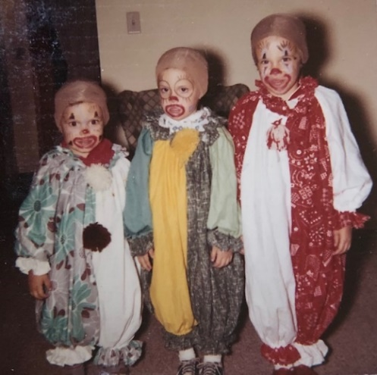

We wore the clown outfits in both 1962, and 1963. This photo is from 1963.

Fri night Ruth and I went to a dedicatory organ recital at the First Presbyterian Church (the other big Pres church – a little nearer downtown than ours). It is a Reuter organ, made in Lawrence, Kansas. They had Dr. Robert Baker from New York for the recital. Yesterday morning Ruth and the kids went to a birthday party for one of Dutch’s children. I went to the bank and came back by for them (over near where we used to live). Ruth went shopping later and we stayed home in the evening.

Ruth is back to normal now. Hope you and Aunt Clara are feeling more rested now. Too bad about Johnny’s boy: I sent them all sympathy cards. Alan now gets 3 words together pretty well and is learning his colors. We must start taking some pictures of the kids so we can send them to all the relatives. My letter writing schedule has certainly become irregular. After we get the refrigerator and chest paid for we want to get a good stereo radio phonograph. Our little phonograph gives trouble all the time and has served well. (It was used and I got it from that Dr. Minz out at Osawatomie, Kansas.) I remember ☺

**11-19-62 – Mon 9:00 PM –** We were glad to have your cards and to hear about everything. Here’s hoping your tests turn out OK. It sounds as if you’ve really had a thorough examination, which I’m sure is for the best. Today was cloudy and cold and they said we may get some of the snow that hit parts of Kansas. It will sure be nice to be so close to work this winter.

It was probably better that you folks didn’t come this past week-end, although, of course, we would have welcomed you. We didn’t get the living room finished painted until last night. I put the curtains up this evening and they look fine with the color of the walls. The color of the walls matches the curtains as closely as we could find. The bottoms of the curtains have to be fixed after some of wrinkles get out and they are ironed. I still have to drill some holes in the wall for the end brackets. The curtains extend beyond the windows. The old curtains only extended over the windows.

Tomorrow night is choir practice rather than Wed before Thanksgiving. Ruth has a contemporary living AAUW meeting tomorrow night. There are 2 or 3 of the AAUW groups that she is interested in. One can go to as many of them as you have time for. Thurs we’ll go over to the Stuarts for Thanksgiving. He is in charge of the patents etc. on new drugs. He is 33, Mormon and has 4 children, the youngest in kindergarten. Our biochemist, Lowell Miller, about my age, will also be there. They have one child. Wish you could be here.

A week ago tonight I put up the curtain brackets. Tues night I painted. Wed I stayed at home while Ruth went to choir practice. Thurs night I stayed home while Ruth went to a creative writing meeting. Last Tues morning Ruth went to the League of Women Voters. Thurs noon she went to Women’s Association at the church. She sang in an ensemble and also had a speaking part. We were home Fri night. Sat morning we went downtown. We ordered a back for the piano as we have turned it out from the wall. About $22. Picked up a refrigerator for the girls’ Christmas. It will match the stove they already have.

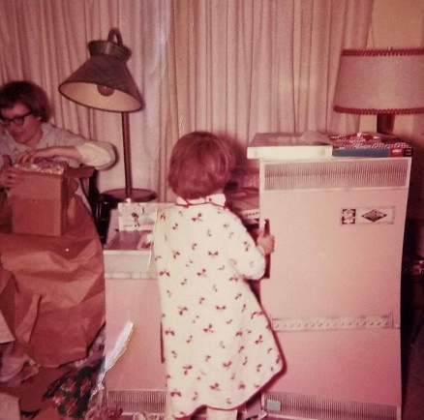 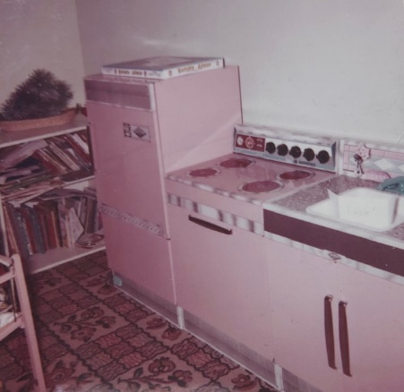

Lisa got the stove for her birthday, and the sink and refrigerator were Christmas gifts.

All three lived in the basement and were well used and well loved.

Sat afternoon Ruth went shopping and I painted in the evening. I missed church as was quite tired and felt like I had a touch of intestinal virus. Alan’s runny nose was enough better so Ruth took all the kids. I felt good enough by yesterday evening to finish the last of the painting. We never did have a caller for the church pledges so Ruth turned ours in Sunday.

A week ago yesterday I stayed home from church with Alan as his nose was quite runny. I started painting the living room ceiling at that time. That is nice that the folks have a new organ. We’ll have to come to Kansas so Ruth can play it. Ruth has never played too much. Again, hope your tests were OK and Aunt Clara is OK.

**11-29-62 – Thurs 7:30 PM –** I’ll write this now and then take it out for mailing later. I’m writing this on the kitchen table. Alan is here also, writing his letter. He is talking more all the time now and gets 3 words together regularly – 4 words together sometimes. For example “Put TV on, My teddy bear, put record on” etc.

We were certainly glad to hear that you’re home now and feeling better. Whats the name of your medicine? I, of course, keep up on major new drugs but don’t keep up on all the new trade names. Our company will soon come out with an improved antacid tablet. It will be sold over the counter but advertised to Drs. Here’s hoping your medicine keeps everything under control and you feel better. They thought Mrs. L had gall bladder trouble once but finally decided it was all due to her ulcer condition which she keeps under control. I guess Mr. L has taken some blood pressure medicine recently. He has been under quite a strain at his new job (1 year at Atwood as principal) since there were a lot of things that needed correcting. They visited Eldons in Denver for Thanksgiving. Eldon may eventually get his doctorate in education but will go back during the summers. They have bought a new house and he has a permanent job as assistant principal.

We hired a new (16 yrs old) babysitter last night and both went to choir practice. This Sunday is the advent sing at which the choir has to sing 2 numbers. I’ve been pretty busy at work and will have a lot of writing to do this next month. The annual company Christmas party is Dec 12th. Ruth has bought material for a new dress and will get some shoes later. Today Ruth planted some tulip bulbs in the planter on the front of the house. I’ve hardly been out in the yard this fall since I mowed it. Being here in the spring next year we’ll get a better start on the yard.

I’ll catch up on the clippings one of these days – I always enjoy them. Today Ruth started making some Christmas cards. She always likes to be creative and make a few. We’re probably too late for picture cards so we’ll enclose some pictures. We haven’t taken any pictures in a long time. Last Sun we all went to church. We sat in the audience as the children’s choir sang in place of the adult one. Ruth wants to know what color M.J. and Bill painted their bathroom. Last Mon they fixed the car $69. Since the car was a wedding present we can’t complain about expenses now; at least it worked well when I was in graduate school and didn’t have as much income. I don’t believe we’ve done anything else unusual. Sorry I didn’t get this off earlier. Give it to Aunt Clara. Again, glad you’re feeling better. Guess I said we had a good dinner over at the Stuarts for Thanksgiving.

**12-7-62 – Thurs 7:30 PM –** I’ll write this and then take it downtown for mailing. We have a Sears order down there to be picked up. It turned cold here yesterday and snowed some. I just tied up the record cabinet and record player as Alan can’t seem to keep out of them. If we get a stereo phonograph for ourselves for Christmas we’ll let the kids learn to use the old one, with their records, but in the meantime we don’t want our records ruined. Alan has a more vociferous temper than the girls did and Ruth says he is like her brother John. We went to library this evening. We usually go once a week to the little branch library near here. It was the girls idea to write you letters so you know they think of you. We have a lot of their recent artwork up on the kitchen cabinets. We were glad to have your letter and to know that you’re feeling better. I’ll enclose the things you wanted back now – they were all of interest. We went to choir practice last night and not much else in the evenings this week. Had a babysitter. Last Sat morning we bought Alan a rocking chair like the girls have. He always wanted to rock when they were, so this will avoid the squabbles.

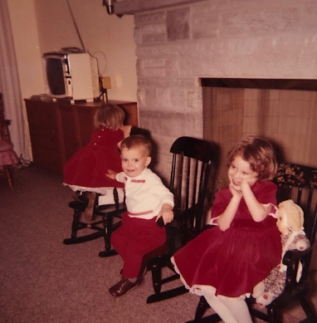 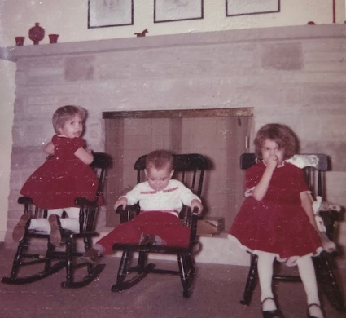

No more fighting over rockers.

I painted some last Sat evening. Ruth had some colitis on Sunday so we had to miss church. She has always had occasional trouble since she had her appendix out in the 5th grade but this was worse than usual. Since she was under no emotional strain to account for it, and was looking forward to the Sun music, she went to see the Dr. on Tues. He couldn’t find anything more than she already knew so there is nothing serious. She now has medicine for it that we hadn’t kept around. I miss the drugstore for prescription things at lower price. Ruth has used the Senokot laxative that Dr. Paine gave you. It is a very good one. The Desicol is a bile salt preparation that, as he said, has been used for many years. We missed the Advent service Sun afternoon at which the choir sang. I got some needed rest myself. I stayed home Mon morning from work and left early Tues afternoon for the Dr. appointment. Plan on coming here when you feel up to it. I’m sure your Blue Cross etc. would be good here and don’t ever worry about getting sick on our hands. Tell MJ and Bill hello.

**12-15-62 – Fri AM –** I didn’t get a letter written last night so will write this note. Glad to have your letter and to know everyone is OK and that you’ve been getting out to meetings, etc. We’ve had a busy week, also. Mon and Tues nights I finished painting in front hallway. Wed night was the Neisler Christmas party. Ruth made a new gold brocade dress with gold shoes.

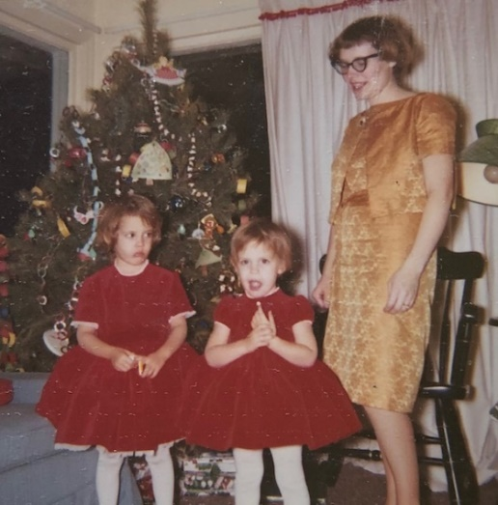

The gold brocade dress. I wish we could see her shoes.

Also, please note that Mom sewed everything you see in the picture; the drapes with red ball fringe, the blue slipcover for the couch, and, of course, all three dresses.

We had a older lady baby sitter. Ruth won $5 on bingo. They danced also. Last night I stayed home while Ruth went to creative writing at AAUW. Yesterday afternoon was association meeting at church. Ruth wore her new dress and was installed as co-music chairman. Tonight the O’Dells (my immediate boss) will be over for dessert. We all made it to church OK last Sun. The kids were thrilled over “The Wizard of Oz” movie over TV last Sun night. Did other odd jobs last weekend. I’m at work so will quit. Love, Ruth, Lesle, Lisa, Alan and Carroll

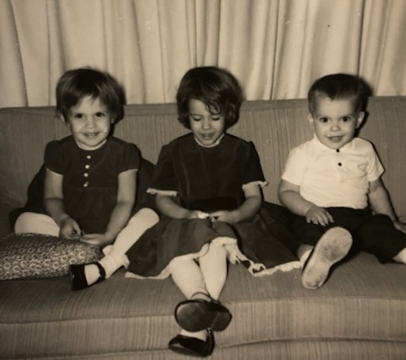

Merry Christmas from 1962!